**Lesson 10 Demo 03**

**Creating a React Redux Testing Application**

**Objective:** To create a React Redux testing application for adding and displaying names using Jest and the testing library

**Tools required:** Node.js and React.js

**Prerequisites:** None

Steps to be followed:

1. Create and set up the React application
2. Create the characterSlice.js and buildStore.js file
3. Create an App.js and App.test.js file
4. Test the application

**Step 1: Create and set up the React application**

1. Open a terminal window to run the following command to create a React application:

**npx create-react-app react-redux-testing**

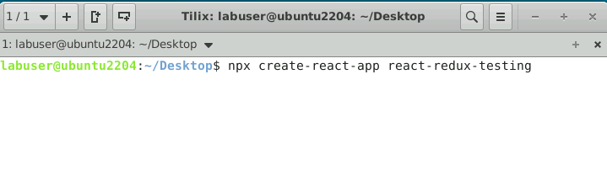

1. Open the created React application folder (**react-redux-testing**) in VS Code by clicking on **File** in the top left corner and selecting **Open Folder**

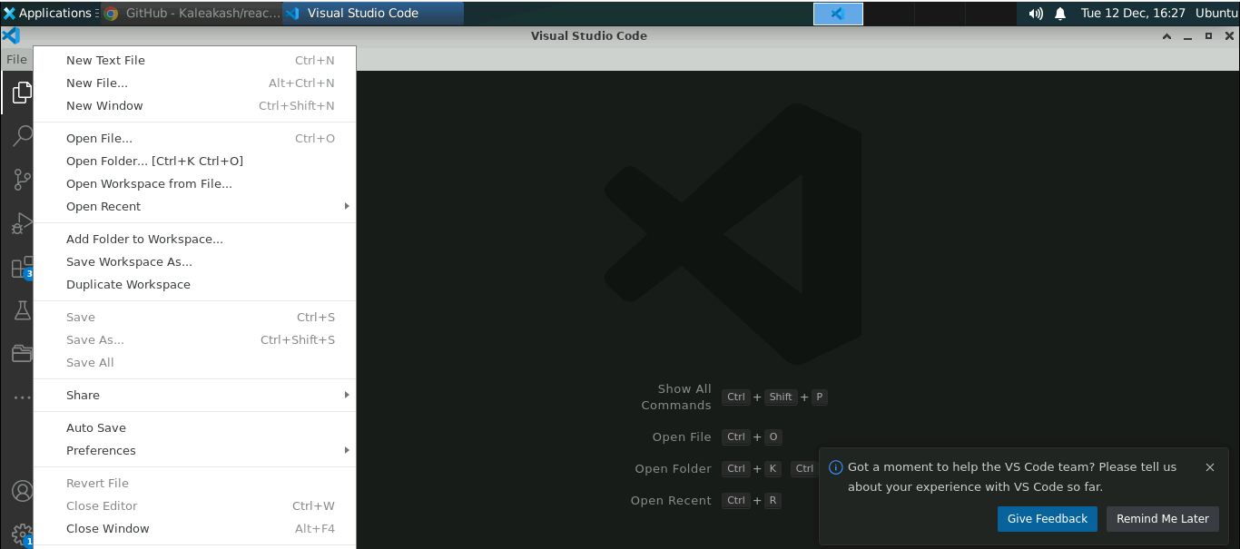

1. Click on **Open** button

The following project structure appears as follows:

1. Inside the project, open the **TERMINAL** and run the following command to install the required dependencies:

**npm install**

1. Open the **package-lock.json** file and view the testing dependencies

**Step 2: Create the characterSlice.js and buildStore.js file**

1. Inside the **src** folder, create the file named **characterSlice.js** and enter the following code:

**import { createSlice } from "@reduxjs/toolkit";**

**const charactersSlice = createSlice({**

**name: "characters",**

**initialState: [],**

**reducers: {**

**add(state, action) {**

**state.unshift(action.payload);**

**},**

**remove(state, action) {**

**state.splice(state.indexOf(action.payload), 1);**

**}**

**}**

**});**

**export default charactersSlice;**

1. Create the file named **buildStore.js** and enter the following code:

**import { configureStore } from "@reduxjs/toolkit";**

**import charactersSlice from "./charactersSlice";**

**export default function buildStore() {**

**const store = configureStore({**

**reducer: charactersSlice.reducer,**

**preloadedState: ["Michael Scott", "Dwight Schrute", "Jim Halpert"]**

**});**

**return store;**

**}**

**Step 3: Create an App.js and App.test.js file**

1. Inside the **src** folder, create a file named **App.js** and enter the following code:

**import { useState } from "react";**

**import { Provider, useDispatch, useSelector } from "react-redux";**

**import charactersSlice from './charactersSlice';**

**import buildStore from "./buildStore";**

**import "./index.css";**

**const store = buildStore();**

**const actions = charactersSlice.actions;**

**export default function App() {**

**return (**

**<Provider store={store}>**

**<OfficeCharacters />**

**</Provider>**

**);**

**}**

**export function OfficeCharacters() {**

**const dispatch = useDispatch();**

**const characters = useSelector((state) => state);**

**const [newCharacter, setNewCharacter] = useState("");**

**function add(e) {**

**e.preventDefault();**

**dispatch(actions.add(newCharacter));**

**setNewCharacter("");**

**}**

**function deleteCharacter(character) {**

**dispatch(actions.remove(character));**

**}**

**return (**

**<div className="container">**

**<form onSubmit={add} className="form-group">**

**<div className="row">**

**<div className="col-2">**

**<label htmlFor="newCharacter">New Names</label>**

**</div>**

**<div className="col-3">**

**<input**

**type="text"**

**id="newCharacter"**

**value={newCharacter}**

**onChange={(e) => setNewCharacter(e.target.value)}**

**className="form-control"**

**/>**

**</div>**

**<div className="col-3">**

**<button className="btn btn-success">Add Names</button>**

**</div>**

**</div>**

**</form>**

**<ol>**

**{characters.map((character, i) => (**

**<li key={i} data-testid="character">**

**<div className="row offset-3">**

**<div className="col-3"> <span data-testid="name">{character}</span>{" "}</div>**

**<div className="col-3"> <button type="button" onClick={() => deleteCharacter(character)} className="btn btn-danger">**

**Delete**

**</button></div>**

**</div>**

**</li>**

**))}**

**</ol>**

**</div>**

**);**

**}**

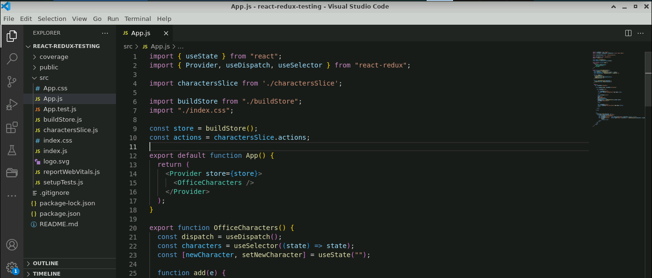

1. Create a file named **App.test.js** and enter the following code:

**import { render, screen, within, fireEvent } from "@testing-library/react";**

**import { Provider } from "react-redux";**

**import buildStore from "./buildStore";**

**import { OfficeCharacters } from "./App";**

**import charactersSlice from "./charactersSlice";**

**describe("OfficeCharacters", () => {**

**function renderOfficeCharacters() {**

**const store = buildStore();**

**render(**

**<Provider store={store}>**

**<OfficeCharacters />**

**</Provider>**

**);**

**return {**

**newCharacter: screen.getByLabelText("New Names"),**

**addButton: screen.getByText("Add Names"),**

**getCharacters() {**

**return screen.getAllByTestId("character").map((item) => ({**

**name: within(item).getByTestId("name").textContent,**

**deleteButton: within(item).getByText("Delete")**

**}));**

**}**

**};**

**}**

**it("should add a character", () => {**

**const { newCharacter, addButton, getCharacters } = renderOfficeCharacters();**

**const pam = "Pam Beesly";**

**// verify pam is NOT in the initial list**

**expect(**

**getCharacters().find((character) => character.name === pam)**

**).toBeFalsy();**

**// add pam**

**fireEvent.change(newCharacter, { target: { value: pam } });**

**fireEvent.click(addButton);**

**// verify pam is first in the list**

**expect(**

**getCharacters().findIndex((character) => character.name === pam)**

**).toBe(0);**

**});**

**it("should delete a character", () => {**

**const { getCharacters } = renderOfficeCharacters();**

**const jim = "Jim Halpert";**

**const deleteJim = getCharacters().find(**

**(character) => character.name === jim**

**).deleteButton;**

**// delete character**

**fireEvent.click(deleteJim);**

**// verify character is NOT in list**

**expect(**

**getCharacters().find((character) => character.name === jim)**

**).toBeFalsy();**

**});**

**});**

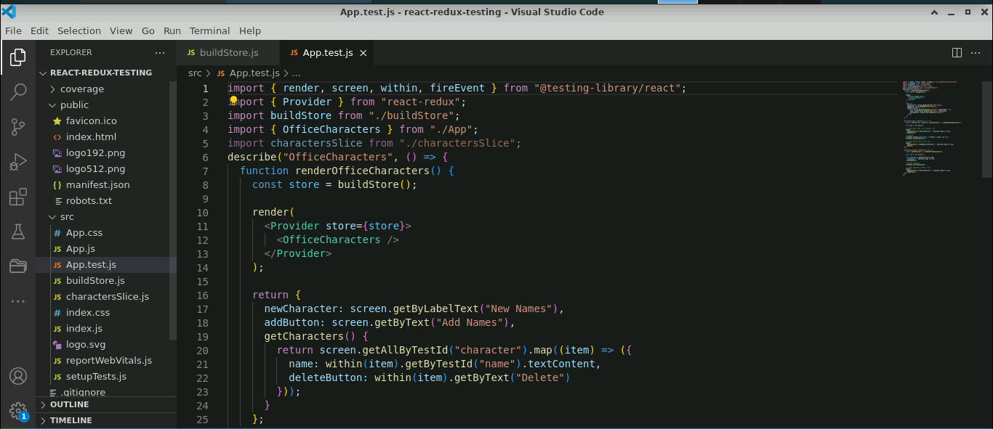

**Step 4: Test the application**

1. Run the following command to test the application as shown below:

**npm test**

The output appears as shown below:

1. Run the following command to execute the application as shown below:

**npm start**



After successful execution, the output can be viewed as shown below:

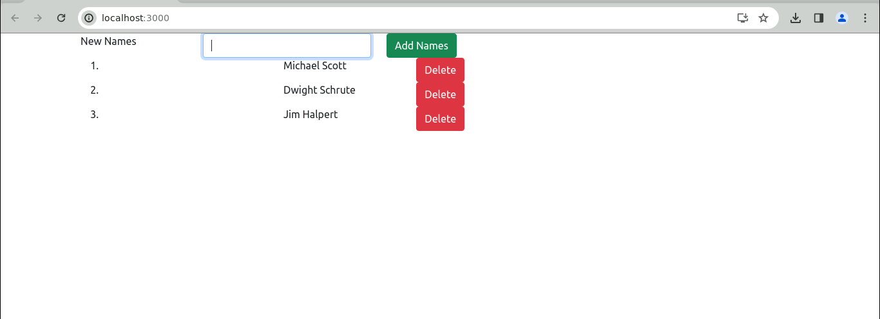

1. Enter the name under the **New Names** and click on the **Add Names** button to add the name

The output appears as shown below:

1. Select any name and click on the **Delete** button (refer to the above screenshot) to delete any name

You have now successfully created the React Redux testing application for adding and displaying names using Jest and the testing library.